Universidad de San Carlos de Guatemala

Facultad de Ingeniería

Escuela de Ciencias y Sistemas

Redes de Computadoras 1

Ing. Pedro Pablo Hernández

Aux. Jhonnatan Enmanuel Orantes García

Erick Javier Bernal Orellana

201480017

**Manual técnico**

**Practica 2**

**Diagrama de la configuración de red.**

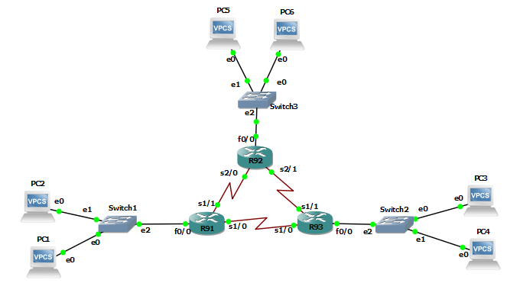

**Generar o activar las conexiones seriales de cada switch**

* Click derecho sobre el swtich
* Seleccionar “configuración”
* Agregar en la ventana de slots, lo indicado en la imagen.

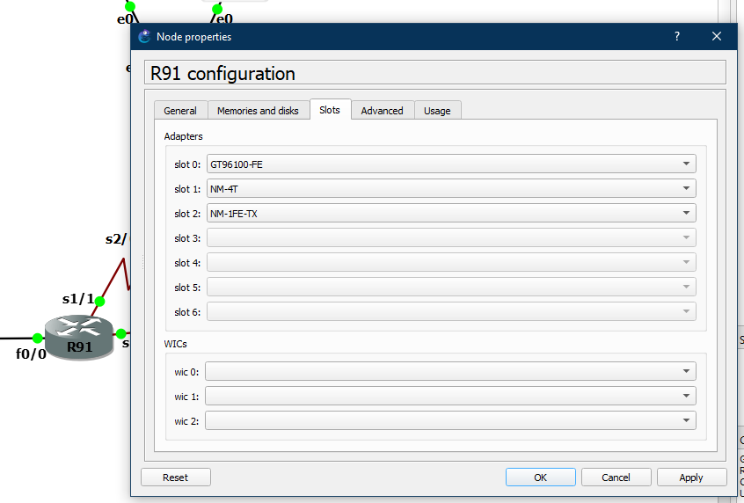

**Configuración de VPCs**

* descripción de asignación de ip
  + Ip <dirección_de_ip> <mascara de sub-red> <gateway>
  + Guardar la ip en cada VPCs
    - save

|  |  |
| --- | --- |
| **VPCs** | **Configuración (asignación de ip)** |
| 1 | ip 192.168.91.10 255.255.255.0 192.168.91.1 |
| 2 | ip 192.168.91.20 255.255.255.0 192.168.91.1 |
| 3 | ip 192.168.93.10 255.255.255.0 192.168.93.1 |
| 4 | ip 192.168.93.20 255.255.255.0 192.168.93.1 |
| 5 | ip 192.168.92.10 255.255.255.0 192.168.92.1 |
| 6 | ip 192.168.92.20 255.255.255.0 192.168.92.1 |

**Configuración de switch hacia VPCs**

|  |  |
| --- | --- |
| **Switch** | **Configuración.** |
| R91 | Conf t  Int f0/0  Ip address 192.168.91.1 255.255.255.0  No shutdown  Exit |
| R92 | Conf t  Int f0/0  Ip address 192.168.92.1 255.255.255.0  No shutdown  exit |
| R93 | Conf t  Int f0/0  Ip address 192.168.93.1 255.255.255.0  No shutdown  exit |

**Configuración entre routers**

* **R91**
  + **R92**
    - Conf t
    - Int s1/1
    - Ip address **172.91.0.2** 255.255.0.0
    - no shutdown
    - exit
  + **R93**
    - Conf t
    - Int s1/0
    - Ip address **172.93.0.1** 255.255.0.0
    - no shutdown
    - exit
* **R92**
  + **R91**
    - Conf t
    - Int s2/0
    - Ip address **172.91.0.1** 255.255.0.0
    - no shutdown
    - exit
  + **R93**
    - Conf t
    - Int s2/1
    - Ip address **172.92.0.1** 255.255.0.0
    - no shutdown
    - exit
* **R93**
  + **R91**
    - Conf t
    - Int s1/0
    - Ip address **172.93.0.2** 255.255.0.0
    - no shutdown
    - exit
  + **R92**
    - Conf t
    - Int s1/1
    - Ip address **172.92.0.2** 255.255.0.0
    - no shutdown
    - exit

**Configuración de Enrutamiento statico.**

* R91
  + R92
    - Conf t
    - Ip route 192.168.**92**.0 255.255.255.0 172.91.0.1
    - exit
  + R93
    - Conf t
    - Ip route 192.168.**93**.0 255.255.255.0 172.93.0.2
    - Exit
* R92
  + R91
    - Conf t
    - Ip route 192.168.**91**.0 255.255.255.0 172.91.0.1
    - exit
  + R93
    - Conf t
    - Ip route 192.168.**93**.0 255.255.255.0 172.92.0.2
    - Exit
* R93
  + R91
    - Conf t
    - Ip route 192.168.**91**.0 255.255.255.0 172.93.0.1
    - exit
  + R92
    - Conf t
    - Ip route 192.168.**92**.0 255.255.255.0 172.92.0.1
    - Exit

Captura de paquetes con wireshark

* Vpcs 5 -> vpcs 3

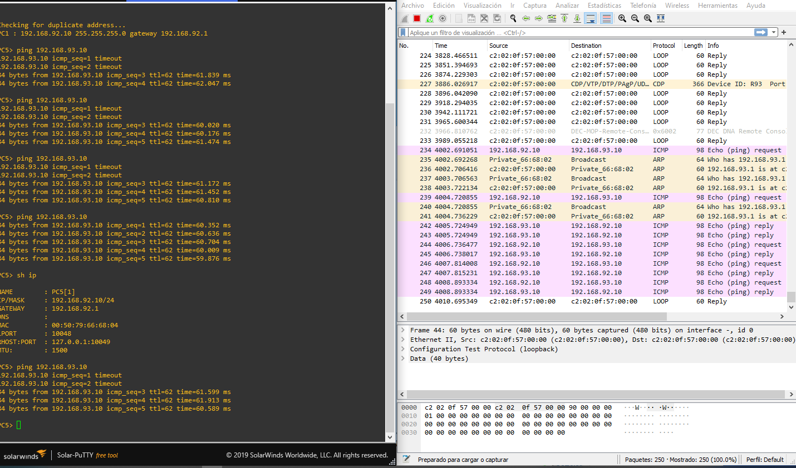

* Vpcs3 -> vpcs5

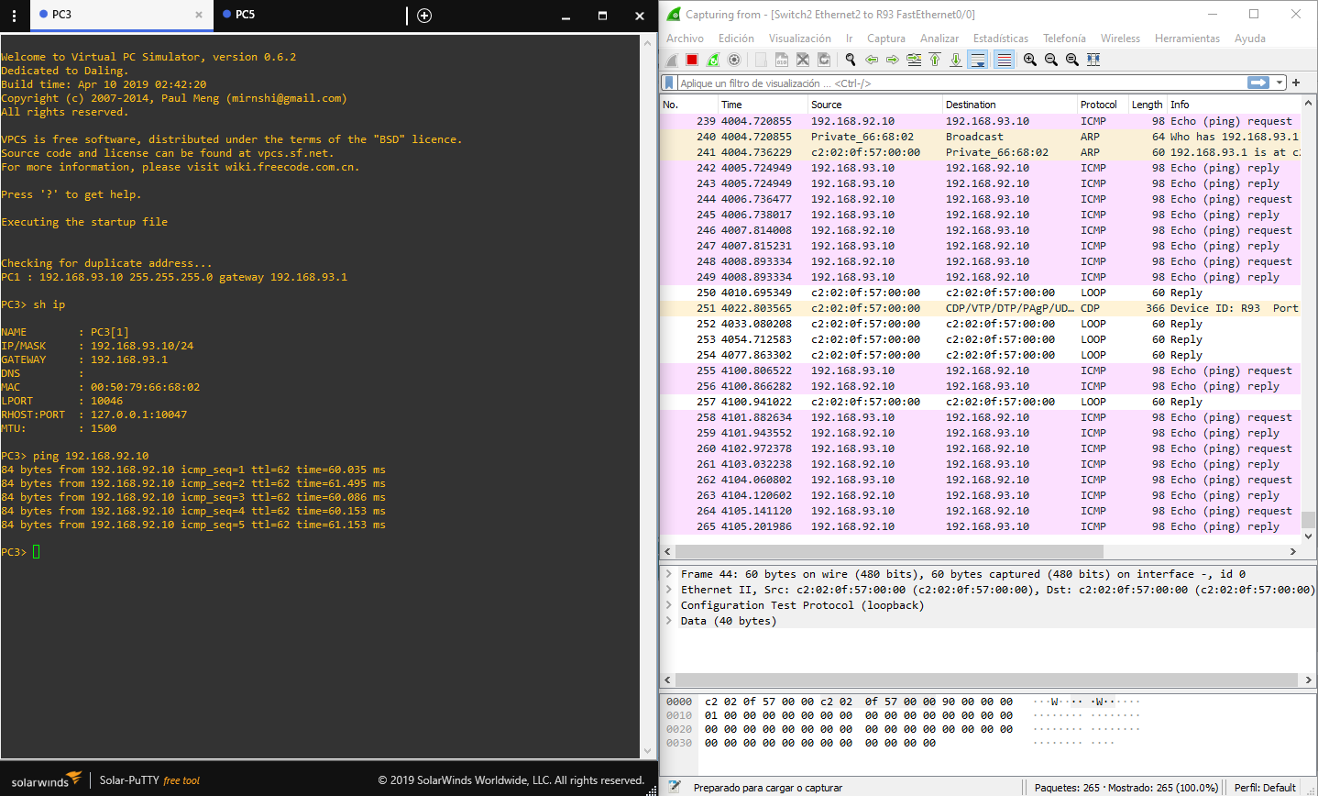

Tabla de ruteo

